MILCONNECT INSTRUCTIONS – INITIATING SM EFORM

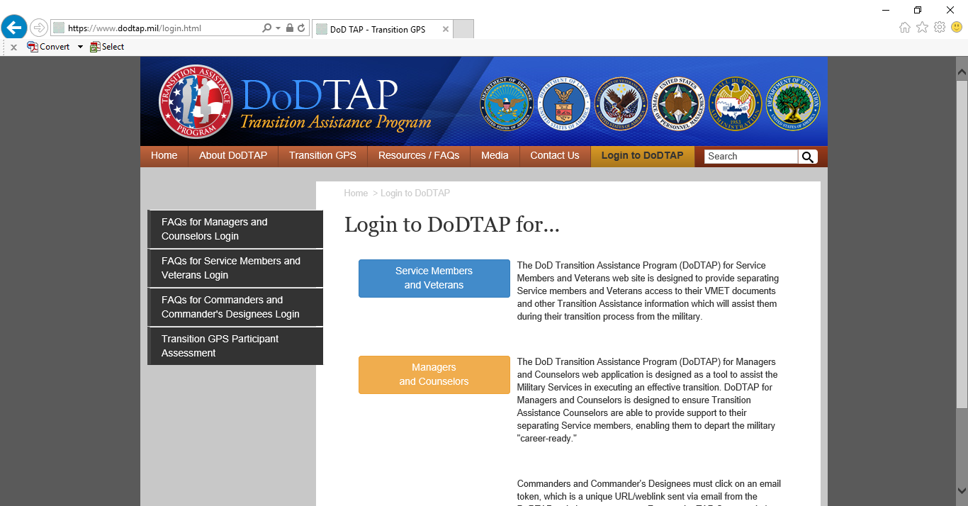
- Step 1 – Log on to www.dodtap.mil. You will be directed to MilConnect.
If this does not work, enter this link: https://milconnectpki.dmdc.osd.mil/milconnect/.

- Step 2 – Select login button (top right). Follow instructions for MilConnect login.
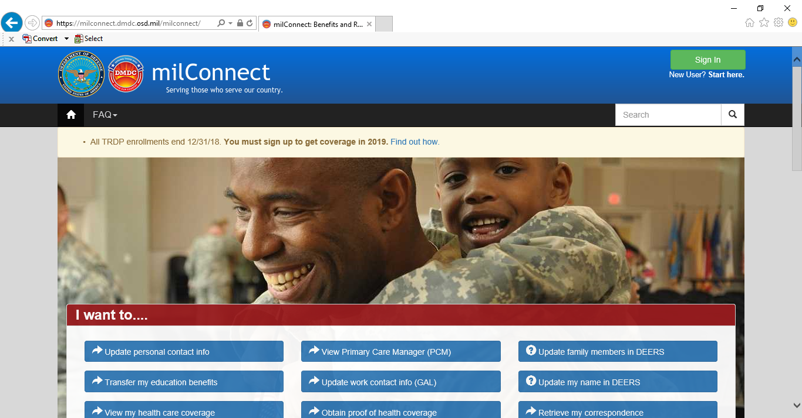

- Step 3 – Select “Correspondence/Documentation” (center tab). Select DoDTAP – last item on list.
- If initiating a new eForm, stay on the “My Dashboard” tab and scroll down to “Initialize Pre-Separation Counseling.” Follow instructions to complete Section I, II and sign and save under Section IV.

