BASIC ALLOWANCE FOR HOUSING

TABLE OF CONTENTS

Flowchart………………………………………………………….………………………………3
Basic Understanding of BAH Entitlements…………………………………………………….4-5
BAH Process Explained Start to Finish…………………………………………………………..6
Dependency Application Checklist………………………………………………………………7
Blank NAVMC 10922………………………………………………………………………....8-9
Dependent Application Explanation…………………………………………………………....10
BAH Package Example…………………………………………………………………..…11-16
References……………………………………….………………………………………......…17

BAH FLOWCHART
Mbr Comes to IPAC to Turn in a Completed BAH Package
Mbr Comes to IPAC to do a Dependent Add/Loss

IPAC Receives Documentation

Conduct an Audit While the Mbr is Present.
Conduct an Audit and Complete a NAVMC 10922 While the Mbr is Present.

Member is Present
Member does not need to be Present
File CART
File CART and BAH Package
After Diary Cycles, Clerk Breaks Down The Diary Checking to Make Sure Entries Posted Correctly in MCTFS
PersO Certifies Diary and Returns to SNCOIC or NCOIC
SNCOIC Double Checks Diary
NCOIC Checks Diary
IPAC Clerk Runs Entries on Diary
Basic Understanding Of BAH Entitlements

Every Marine rates a type of BAH. There are seven different types of BAH: BAH-Partial, BAH-Without, BAH-With, BAH-Diff, BAH-T, BAH-RC, FSH. Each one is explained further in the JFTR Chapter 10. The main focus of this turnover is to focus on the first four types listed above for Marines that are not married to another service member including.
BAH-Partial is explained in JFTR paragraph U10010 and is for when a Mbr resides in Barracks and is not
in receipt of BAH
BAH-Without is explained in JFTR Section E1 and is for Mbrs that rate BAH without dependents.
BAH-With is explained in JFTR Section E2 and is for Mbrs who rate BAH with dependents
BAH-Diff is explained in JFTR paragraph U10008 and is for Mbrs who may rate BAH-Without or BAH-P
but pay child support
BAH Without
All Marines without dependents and below E-6 must fill out a BAH request form found on the MFR SharePoint under the HQBN S-4 site. Typically SSgt’s are guaranteed BAH-Without and Sgt and below are case by case. The BAH request will be routed through the Mbr’s Chain of Command. Typically these requests are handled through the Inbound Section during the check-in process but may be taken care of in the Active Maintenance. Once the request is approved appropriate action will be taken to report on diary (refer to UDMIPS Turnover) then file away in the BAH Package Binder for record purposes and original is filed with Mbr’s SRB. All approved BAH Packages are kept in Active Maintenance.
BAH With
If Mbr has dependents previously approved all that is required is verification of the dependents information for accurate information and that Mbr is in receipt of correct BAH entitlements. If a Mbr needs to add a dependent then a determination needs to be made whether or not a member can claim a dependent. The determination is found in MCO P1751.3_ Dependency Determination and BAH Manual. Once the determination is made then a NAVMC 10922 Dependency application needs to be completed IAW MCO P1751.3_ Dependency Determination and BAH Manual Chapter 1 and Figures 1-3 through 1-16. Complete an audit of the BIR and RED (Refer to Triennial Audit Turnover) ensuring dependent information is added correctly, then report on diary IAW UDMIPS Turnover.
Dependent loss may or may not change the status of with or without depending if there are other dependents or not. In either case a new NAVMC 10922 needs to be completed showing the loss of the dependent and appropriate action taken to report on diary IAW UDMIPS Turnover.
Supporting Documentation will be Birth Certificates, SSN Card, Driver License, and Marriage Certificate for dependent add; Divorce decree or death certificate for dependent loss.
BAH Diff
A Mbr that is in receipt of BAH-Without or BAH Partial may be entitled to BAH-Diff if the guidelines in the references above are met. If a Mbr is in receipt of BAH-Without and qualifies for BAH-Diff they will receive BAH-With at the DIFF rate. All this means is the BAH is equal to the same amount as if the Mbr was receiving BAH-With. It will make more sense once it is reported on diary. If a Mbr is in receipt of BAH-Partial and qualifies for BAH-Diff then BAH-Diff will be entered and the Mbr will receive BAH-Partial along with the difference between With and Without. Basically BAH-Diff is put in place to help offset the cost of child support. The catch is that the Mbr’s support check must be greater than or equal to the difference of BAH With and Without.
Supporting Documentation includes: Child Affidavit, Custody Agreement, and Notarized Letter Stating the Amount of Child Support Paid
BAH Process Explained Start to Finish
Dependent Add/Loss
The member will come into the IPAC to have a dependent put in or taken out of the system. The processes for both are similar.
Dependent Add
Before the process is started the member must provide source documentation. If it is a marriage they will need to provide a birth certificate, SSN card, and marriage certificate. If it is a legitimate child they will need to provide birth certificate and SSN card. If it is a child out of Wedlock they will need to provide a custody agreement, proof of paternity, child affidavit, and proof of child support.
Dependent Loss
For a dependent loss a member will provide a divorce decree or proof of death.
Audit/NAVMC 10922 Dependent Application
Conduct a full audit of the BIR, RED, W-4, and SGLI. The dependent application also needs to be completed. A blank example is further down in the turnover along with a brief explanation of each section. Because of the many different scenarios that may occur it is recommended to follow the examples located in MCO P1751.3F.
Run Entries on Diary
At this point the member is no longer needed. All entries should be ran on diary within 3 days of conducting the audit. After entries are ran on diary the diary is given to the NCOIC then the SNCOIC to be checked for corrections. Once the Diary is correct they will then turn it in to the PersO where they will certify the diary and return it back to the NCOIC or SNCOIC.
After the next cycle day verify everything posted VIA MCTFS. When all entries are verified correct in MCTFS it is then time to break down the diary and file it away.
BAH Package Approval
This process is the same as a dependent add minus the NAVMC 10922. The source doc needed for this is the BAH Package located on the MFR SharePoint HQBN S-4. An example is also located later in this turnover. The member is to have it filled out and routed via his chain of command and signed off by the CO. Ensure to tell the member to include any source docs that benefit their case. After everything is ran on diary, certified and broken down ensure a copy of the BAH package is filed in the BAH package binder and the original is filed in the members book.

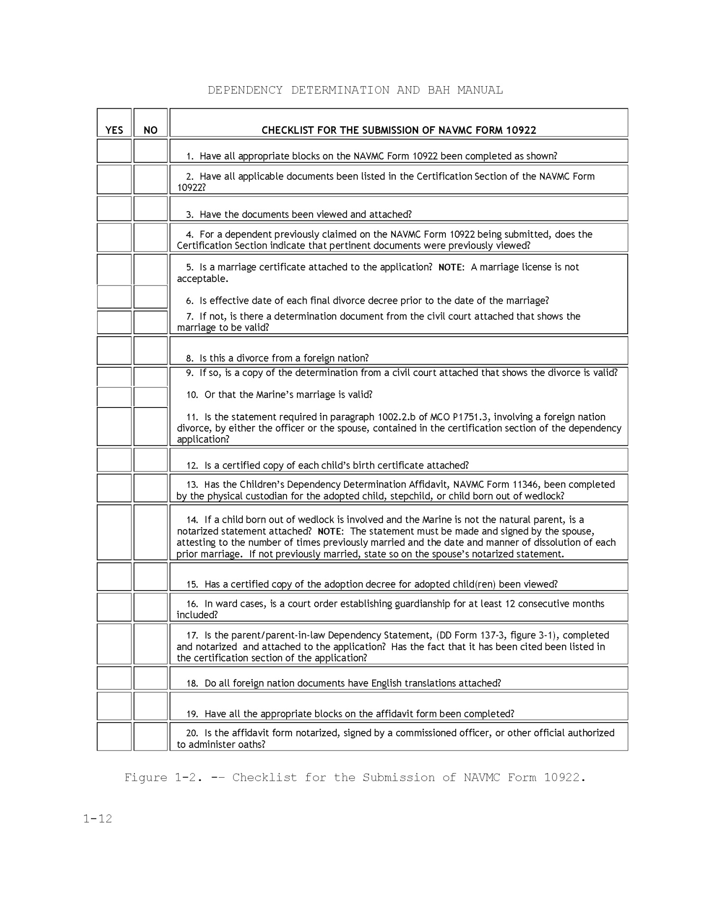
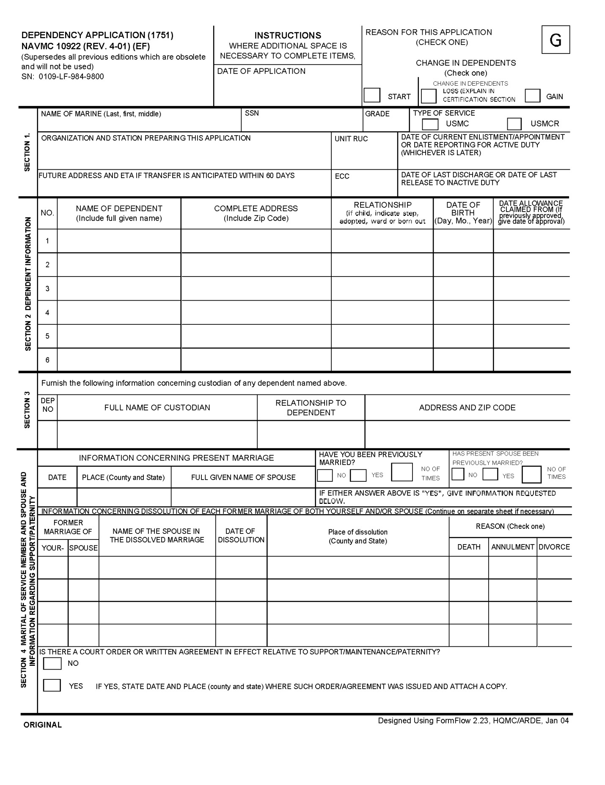
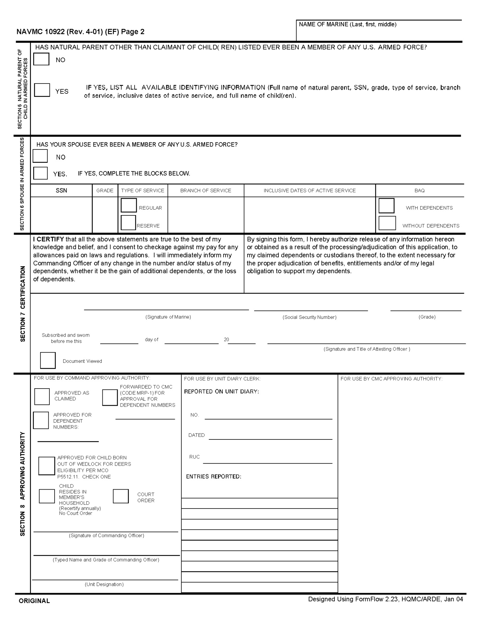
Dependent Application Explanation
Note: Some blocks may not allow you to fill them electronically, it is ok to pen write in black ink neatly.
Section 1- These blocks are self explanatory and can be found on the BIR and current contract or enlistment located in the SRB/OQR
Section 2- This information is verified by the source docs provided by the member such as marriage cert, birth cert, SSN card, drivers license, divorce decree, or death cert. Date of Allowance claimed from will be the date of marriage or birth. If member was previously approved then annotate above the date.
Section 3- If there is a child as a dependent a custodian must be provided. Typically it is the spouse, but may be anyone the member elects to take care of their child.
Section 4- Enter the current marriage information. Make sure to annotate whether or not they were married before and how many times and fill in the information about each previous marriage for both member and spouse.
Section 5- Self explanatory.
Section 6- Self explanatory.
Section 7- Self explanatory. Be sure to check Documents Viewed and type the documents viewed. An example would be: Birth Certificate, SSN Card, and Marriage Certificate. Signature and Title of Attesting Officer typed format will be FI. MI. LAST NAME RANK
Section 8- Mark the appropriate box. Type the PersO name and Unit Designation. After the application has been signed and reported on diary be sure to put the diary number, date, and RUC. Include all the entries ran on diary. An example would be BIR Audit, RED Audit, SGLI Audit. Typed Name and Title of Commanding Officer will be in the format of FI. MI. LAST NAME RANK.
Common Diary Entries for a Dependent Add/Loss
088-000 Dependent Addition
089-000 Dependent Loss
423-001 Number of Dependents
388-001 Change BAH
343-000 RED Spouse
343-001 RED Child 1
343-023 RED Additional Death Grat
343-022 RED Person Auth Direct Disposition Name
343-011 RED Pay Arrears1
347-000 RED SGLI Pay Desig Beneficiary
816-000 Dependent BAH Cert Date

UNITED STATES MARINE CORPS
HEADQUARTERS BATTALION
MARINE FORCES RESERVE
4400 DAUPHINE STREET
NEW ORLEANS, LOUISIANA 70146-5400

IN REPLY REFER TO:
11240
S4

From: __________________________________________________________
(Rank) (Last Name) (First Name) (MI) (SSN/MOS) (SECTION)

To: Commanding Officer
Via: Chain of Command

Subj: REQUEST FOR BASIC ALLOWANCE FOR HOUSING (BAH) WITHOUT
DEPENDENTS

Encl: (1) Financial Worksheet
(2) Letter/Statement from future landlord

1. It is requested that I be authorized to reside on the economy and receive BAH without dependents.

- My anticipated date to move is:
I intend to reside at:
- My phone number is (If known)
- My rent will be :

2. The reason for this request is as follows:

3. I understand that I must submit this request 30 days prior to my anticipated date to move. My BAH will not be effective until I check out of the Bachelor Enlisted Quarters (BEQ), turn my room key into the BEQ Manager, and turn in the paperwork to the Battalion S-1. I also understand that I am not authorized to move out of the barracks until this request is approved by the Commanding Officer (CO).

4. I further understand that if my request is approved my BAH can be terminated at any time if my financial situation changes, subject of disciplinary action, or if the CO deems it necessary. Additionally, I will bear the responsibility of any and all costs incurred resultant to the loss of BAH (i.e. remaining balance from the rental or leasing agreement, storage of furniture, etc.)

5. Enclosures (1) and (2) are provided as supporting documents.

___________________________
PRINT AND SIGNATURE

Subj: REQUEST FOR BASIC ALLOWANCE FOR HOUSING (BAH) WITHOUT
DEPENDENTS
ADJ
________

FIRST ENDORSEMENT

From: Staff Noncommissioned Officer in Charge

1. Forward recommending approval/disapproval. Reason (required for all disapprovals):
____________________________________________________________________________________________________________________________________________

__________________________
PRINT AND SIGN (RANK)
----------------------------------------------------------------------
ADJ
_________

SECOND ENDORSEMENT

From: Officer in Charge

1. Forward recommending approval/disapproval. Reason (required for all disapprovals):
____________________________________________________________________________________________________________________________________________

_________________________
PRINT AND SIGN (RANK)
----------------------------------------------------------------------
ADJ
_________

THIRD ENDORSEMENT

From: Battalion S-4 Chief (BEQ Manager)

1. Forward recommending approval/disapproval. Reason (required for all disapprovals):
____________________________________________________________________________________________________________________________________________

___________________________
PRINT AND SIGN

Subj: REQUEST FOR BASIC ALLOWANCE FOR HOUSING (BAH) WITHOUT
DEPENDENTS
ADJ
_________

FOURTH ENDORSEMENT

From: Battalion Adjutant

1. Forward recommending approval/disapproval. Reason (required for all disapprovals):
____________________________________________________________________________________________________________________________________________

___________________________
PRINT AND SIGN
----------------------------------------------------------------------
ADJ
_________

FIFTH ENDORSEMENT

From: Battalion Sergeant Major

1. Forward recommending approval/disapproval. Reason (required for all disapprovals):
____________________________________________________________________________________________________________________________________________

___________________________
PRINT AND SIGN
----------------------------------------------------------------------
ADJ
_________

SIXTH ENDORSEMENT

From: Battalion Executive Officer

1. Forward recommending approval/disapproval. Reason (required for all disapprovals):
______________________________________________________________________

___________________________
PRINT AND SIGN

Subj: REQUEST FOR BASIC ALLOWANCE FOR HOUSING (BAH) WITHOUT
DEPENDENTS
ADJ
__________

SEVENTH ENDORSEMENT

From: Commanding Officer
To: _______________________________________________________________
(Rank) (Last Name) (First Name) (MI) (SSN/MOS)
Via: Battalion S-4 Chief (BEQ Manager)

1. □ Approved for BAH. Effective date will be the date you check out of the BEQ, turn in your room key, and turn in the housing paperwork to the BN S4 Chief (BEQ Manager).

□ Approved for BAH. Effective date is _______________. You currently do not reside in Government Housing.

□ Approved to be added to the waiting list. The waiting list effective date is __________. The current occupancy rate is below 95%

When the occupancy rate reaches 95%, those personnel on the waiting list, ranked by waiting list effective date, will be afforded the opportunity to move out. The effective date to start your BAH, at that time, will be the date that your housing paperwork to the BN S4 Chief (BEQ Manager).

Disapproved for the following reason:

_______________________________________________________________
___________________________________________________________________________________________________________________________________________________________________________.

T. D. FORD

Copy to:
IPAC
Files

FINANCIAL WORKSHEET

I. INCOME INFORMATION

1. Base Pay. . . . . . . . . . . . . . . . . . . . .$_____________
2. ComRats/BAS (if approved) . . . . . . . . . . . .$_____________
3. Part Time Job . . . . . . . . . . . . . . . . . .$_____________
4. Other Income. . . . . . . . . . . . . . . . . . .$_____________
5. BAH (if approved) . . . . . . . . . . . . . . . .$_____________
6. Total Income. . . . . . . . . . . . . . . . . . .$_____________

II. MONTHLY DEDUCTIONS

1. Federal Tax (FITW). . . . . . . . . . . . . . .$_____________
2. State Tax (SITW). . . . . . . . . . . . . . . .$_____________
3. Social Security . . . . . . . . . . . . . . . .$_____________
4. Medicare. . . . . . . . . . . . . . . . . . . .$_____________
5. SGLI. . . . . . . . . . . . . . . . . . . . . .$_____________
6. Allotment/Other . . . . . . . . . . . . . . . .$_____________
7. Allotment/Other . . . . . . . . . . . . . . . .$_____________
8. Allotment/Other . . . . . . . . . . . . . . . .$_____________
9. Charity Allotment . . . . . . . . . . . . . . .$_____________
10. Garnishments. . . . . . . . . . . . . . . . . .$_____________
11. Dental. . . . . . . . . . . . . . . . . . . . .$_____________
12. Total Deductions. . . . . . . . . . . . . . . .$_____________

III. MONTHLY EXPENSES

1. Savings Deposit . . . . . . . . . . . . . . . .$_____________
2. Rent. . . . . . . . . . . . . . . . . . . . . .$_____________
3. Utilities1 (Gas/Electricity). . . . . . . . . .$_____________
4. Utilities2 (Water). . . . . . . . . . . . . . .$_____________
5. Utilities3 (Trash). . . . . . . . . . . . . . .$_____________
6. Groceries . . . . . . . . . . . . . . . . . . .$_____________
7. Phone . . . . . . . . . . . . . . . . . . . . .$_____________
8. Cable TV. . . . . . . . . . . . . . . . . . . .$_____________
9. Auto Payments . . . . . . . . . . . . . . . . .$_____________
10. Auto Maint (Fuel/Etc) . . . . . . . . . . . . .$_____________
11. Auto Insurance. . . . . . . . . . . . . . . . .$_____________
12. Credit Card1. . . . . . . . . . . . . . . . . .$_____________
13. Credit Card2. . . . . . . . . . . . . . . . . .$_____________
14. Other . . . . . . . . . . . . . . . . . . . . .$_____________
15. TOTAL EXPENSES. . . . . . . . . . . . . . . . .$_____________

IV. BOTTOM LINE NET FUNDS AVAILABLE

1. TOTAL AVAILABLE. . . . . . . . . . . . . . . . .$_____________

______________________
SIGNATURE

References:
MCO P1751.3F-Dependency Determination And Basic Allowance For Housing (Bah) Manual
http://www.marines.mil/unit/hqmc/hqbat/Documents/BAH%20Manual.pdf

JFTR Chapter 10
http://www.defensetravel.dod.mil/Docs/perdiem/JFTR(Ch1-10).pdf

MFR SharePortal
https://portal.marforres.usmc.mil/sites/mfr/Pages/Default.aspx

